Business Requirement Document (BRD) for TransMatch
Project Overview
Project Name: TransMatch
Description: A customer screening software solution designed to streamline the process of cross-referencing customer information with bank statements and generating detailed, exportable reports.

Business Objectives
- Automate Customer Screening:
  - Enable efficient matching of customer names with bank statements.
  - Provide detailed reports to ensure compliance and reduce manual errors.
- Enhance User Experience:
  - Simplify data entry and processing through an intuitive user interface.
  - Offer offline capabilities for seamless operations without constant internet access.
- Secure Data Management:
  - Implement robust security measures to protect sensitive customer data.
  - Ensure role-based access control to define user permissions.

Scope of Work
Key Features and Functionalities
- Transaction Module:
  - Support for Document Upload (PDF format) for automated data extraction.
  - Manual Input Screen for direct user data entry.
  - OCR Integration to process handwritten text from images and validate extracted data.
  - Data Enrichment to allow selection, editing, and updating of database records.
- Administration Module:
  - Manage user groups, roles, and menu access permissions. Menu enablement and visibility are configured based on the user group, role, and rights. For example:
- Transaction Menu: Accessible by Group A and B with the role of Data Entry.
- Administration Menu: Accessible by Group A with the Admin role.
- Report/Enquiry Menu: Accessible by Group B with the Admin role.
As a result, users in Group A will not see the Report/Enquiry menu.
- Define role-based access control for different levels of system usage.
- Report/Enquiry Module:
  - Generate and export matched customer data into Excel files. The system will provide screens for data enquiry with filtering options based on the following criteria:
    - User Group
    - User Role
    - Data Entry Source d.
    - Data Entry Date
    - Customer Name
    - Bank
    - Bank Transaction Date
    - Printed Status (indicates if the record has already been included in the final report).
  - Provide Key Performance Indicators (KPI) reports for user activity (weekly, monthly, yearly).
- Security Features:
  - Encrypt data stored locally and in the cloud.
  - Implement access control using a defined user matrix.
- Backup and Recovery:
  - Use cloud-based services (Digital Ocean) for scheduled database backups.
  - Provide recovery mechanisms to restore data in case of failures.

Functional Requirements
User Roles and Permissions
- Superuser (default user):
  - No restrictions on functions or menu access across the entire system.
  - This role is exclusively held by the system owner.
- Admin (configurable role):
  - Full system access, including user management and system configuration.
- Data Entry User (configurable role):
  - Access to Transaction Module for data entry and updates.
- Viewer (configurable role):
  - Restricted access to view reports and KPIs.
System Behavior
- Automatically validate imported files for format and completeness.
- Allow manual review and correction of OCR-processed data before saving.
- Provide data enrichment to allow users to view and edit incorrect data for validation before saving.
- Provide audit logs for administrative and data entry activities.

Non-Functional Requirements
- Performance:
  - System should be capable of processing multiple data inputs from different users simultaneously. It should perform fast and reliable data parsing, data mapping, and data report generation within a short period of time.
- Scalability:
  - Support additional modules or features as the business grows.
- Reliability:
  - Ensure at least 95% system uptime per week with fallback mechanisms.
- Security:
  - Comply with industry standards for data protection and encryption.
- Usability:
  - Provide an intuitive and user-friendly interface.

Assumptions and Constraints
- Users will have basic training on system usage before deployment.
- Internet connectivity is required for cloud-based functionalities.
- The database (PostgreSQL) will be managed on a cloud-based platform (Digital Ocean).
- System updates and maintenance will be scheduled during off-peak hours to minimize disruptions.

Deliverables
- Fully functional Transaction Module with data entry capabilities.
- Configurable Administration Module for role and access management.
- Comprehensive Report/Enquiry Module for data export and KPI tracking.
- Documentation, including user guides and maintenance plans.
- Deployment of the software with 3 months of free bug fixes.

Screen Design
- Login Screen:

- Transaction Module:
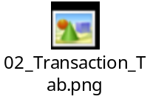
- Administration Module:
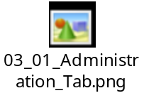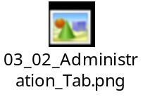
- Report/Enquiry Module:
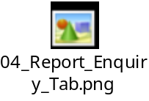
  - Generate Report:
    - View – Superuser

    - View – Agent
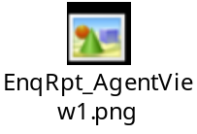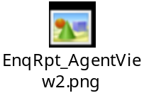
    - Export – Plaint Text
